MS SQL SERVER
Standard Operating Procedures
(SOP)
SQL Server Log Shipping in SQL server

Submitted to



BY



CIS, Wipro Limited

Document Details

Project Name | Innogy SE
Account | CIS
IT Component/Application Title | SQL Server Log Shipping in SQL server
Current Version | 1.5
List of Contributors | Pradipkumar Kansara, Kiran Bhalekar, Ayushi Gautam, Sivakumar Goud, Nanda Kishore Reddy
Customer Contact Information

Version History
(All revisions made to this document must be listed in chronological order. All revisions must be approved. Review and Approval can be done by an internal source or by the customer)
Version | Date of Revision | Description | Author | Reviewed By | Approved By
1.0 | 29-08-2015 | Initial Draft | Kiran Bhalekar | Pradipkumar Kansara | Mahesh Keshatwar
1.1 | 04-09-2015 | Document Completed | Kiran Bhalekar | Pradipkumar Kansara | Mahesh Keshatwar
1.2 | 21-08-2016 | Updated document to standard format | Kiran Bhalekar | Pradipkumar Kansara | Mahesh Keshatwar
1.3 | 17-05-2017 | Wipro and Innogy Logo changed | Sivakumar Goud | Pradipkumar Kansara | Mahesh Keshatwar
1.4 | 14-09-2017 | Updated document to Wipro Standard format with header and footer | Sivakumar Goud | Pradipkumar Kansara | Santosh Badiger
1.5 | 11-11-2018 | Updated the content | Nanda Kishore Reddy | Pradipkumar Kansara | Santosh Badiger

Document Distribution List
Sl. No. | Name and Company | Purpose
1 | RWEIT-SQLDBA | Document is useful for configuring Log shipping.
2

TABLE OF CONTENT
1. Purpose 1
2. Scope 1
3. Log Shipping 1
3.1 Log Shipping Fundamentals 1
3.2 Configuring Log Shipping 2
Step 1: Register The Dr Server In The Primary Server And Vice Versa 2
Step 1.1: Login To The Primary Site Sql Server Management Studio. 2
Step 1.2 Open New Registration Window: 2
Step 2: Configuring Log Shipping Settings 5
Step 2.1: Login To The Primary Site Server And Open The Sql Server Management Studio. 5
Step 2.2: Give The Net Work Path For Back Up Folder. 6
Step 2.3: Schedule The Backup. 7
Step 2.4: Secondary Server Settings 8
Step 2.4.1: Give The Secondary Database File Restore Path 9
Step 2.4.2: Give The Schedule Copy, Restore Jobs Details 9
4. Reference 12

- Purpose
This document is prepared for the management and troubleshooting of SQL Server Database Administration Services at <Customer Name>.

2. Scope
This document is prepared for GSMC Wipro sustenance team and provides the concepts, management and troubleshooting aspects of Log Shipping for the administration of the SQL Server database at <Customer Name>.

3. Log Shipping

3.1 Log Shipping Fundamentals
Log shipping is a native SQL Server high-availability technology, which is essentially a continuous backup and restores operation. Log shipping involves copying a database backup and subsequent transaction log backups from the primary (source) server and restoring the database and transaction log backups on one or more secondary (destination) servers. The database and transaction logs are restored on the secondary servers in standby or no-recovery mode, which allows subsequent transaction logs to be backed up on the primary and shipped (or copied) to the secondary servers and applied there.
The standby mode allows users to access the restored database, but will not allow them to make any changes to it and will allow future log backups to be restored to the database.
The no-recovery mode does not allow users to access the database and allows future transaction log backups to be restored to the database.
Log shipping makes it possible to keep the primary (source) and the secondary or standby server in sync on a per-database level.

3.2 Configuring Log Shipping

Step 1: Register the DR Server in the Primary server and vice versa

Step 1.1: Login to the primary site SQL Server Management studio.
The Management Studio will have the below appearance:
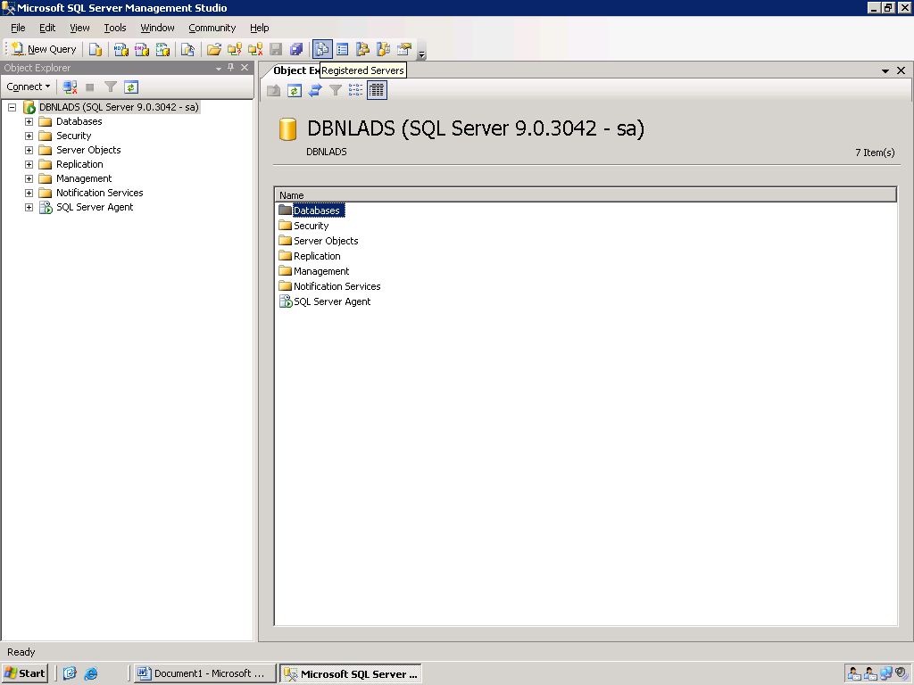

Step 1.2 Open New Registration Window:
Right click on the SQL Server Group. Click on Open>Server Registration… as shown below:

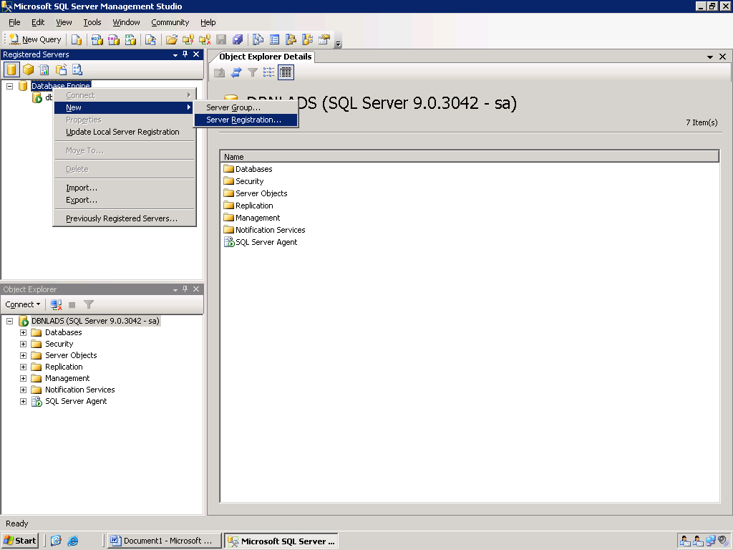

The New Server Registration Window will look as follows:
Enter the DR Server Name; Authentication Mode and login username and password and click save
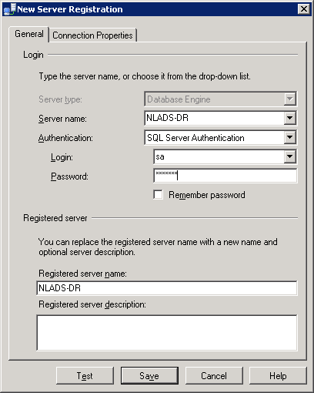

After registration the new database will appear as in below screen:
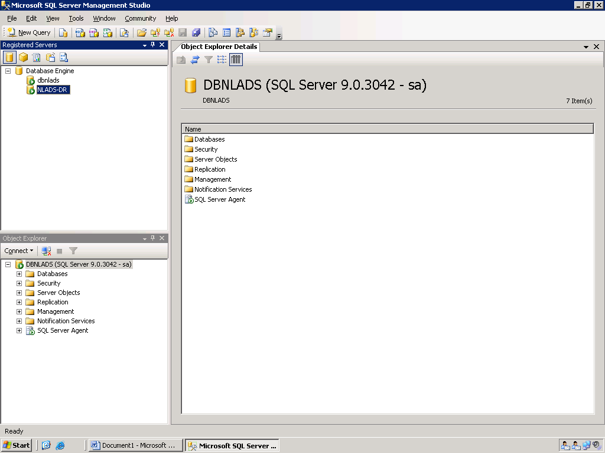

Right Click on the newly registered database (NLADS-DR) > Object Explorer.

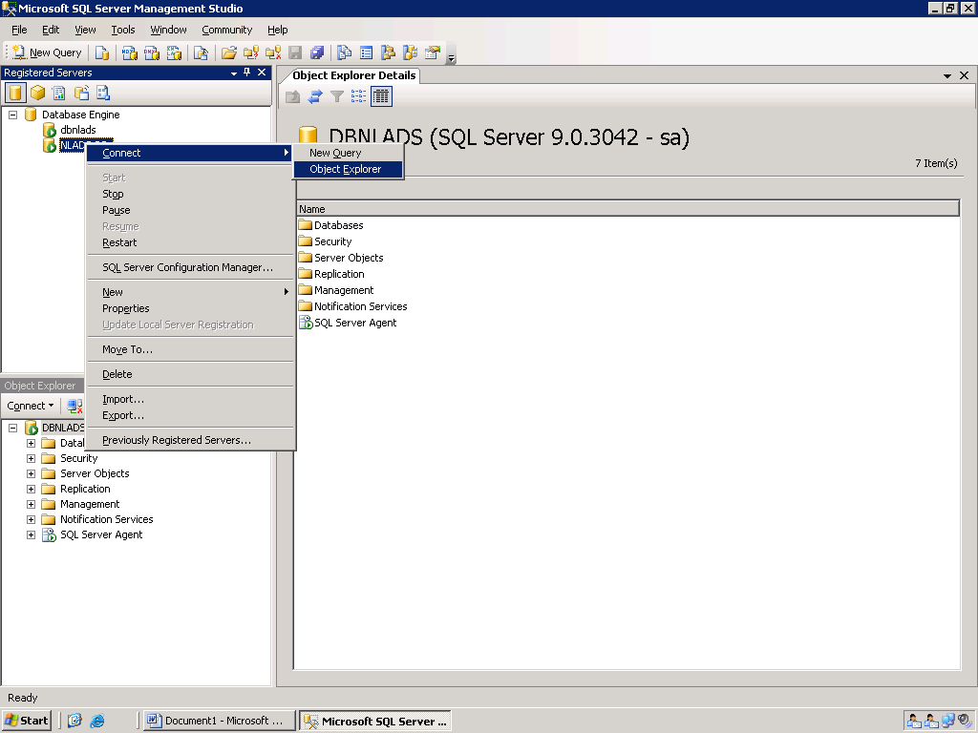

Follow the same steps as above in the DR server to register the primary server.

Step 2: Configuring log shipping settings

Step 2.1: Login to the primary site server and open the SQL Server Management Studio.
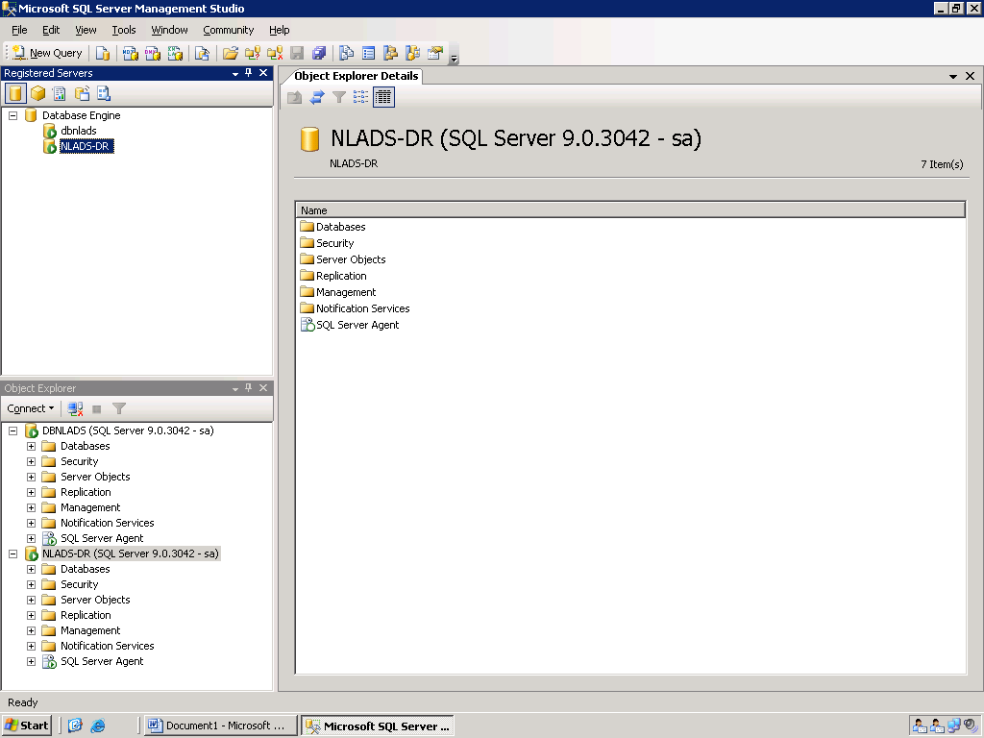

Right click database select properties of the database in primary.
This wizard will appear as follows:
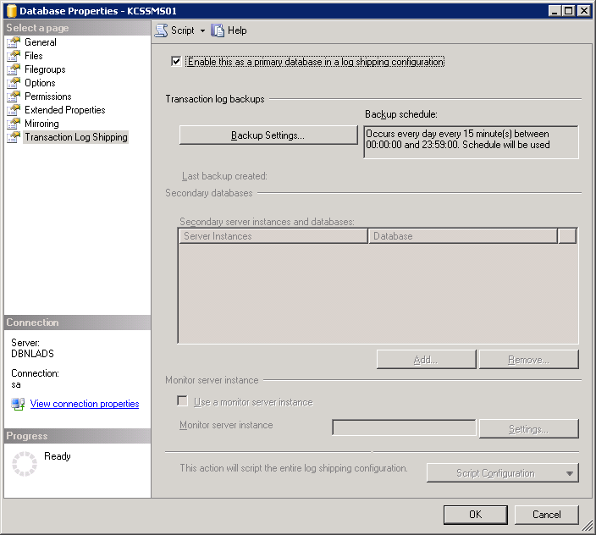

Select the Check box for “Enable the primary database to log shipping”
Click “Backup Settings” to get the following screen

Step 2.2: Give the net work path for back up folder.
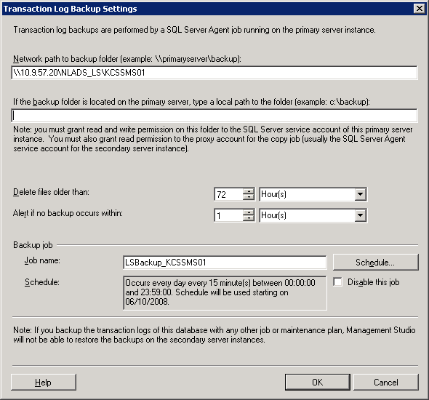

Step 2.3: Schedule the backup.
Click on schedule (if u wants to change default time)

Schedule the log back job

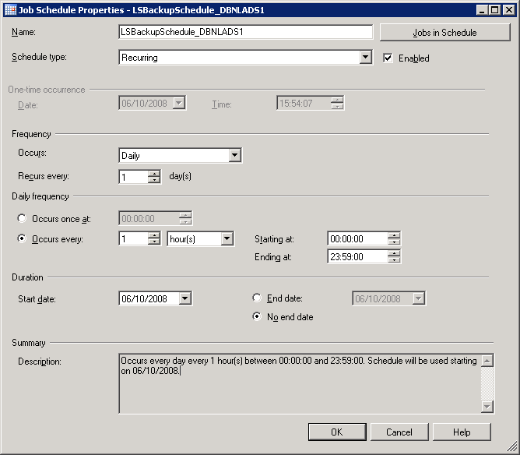
Click ok.

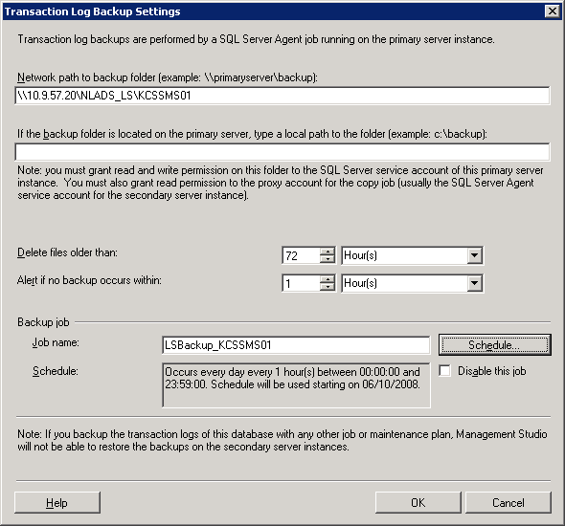
Click ok.

Step 2.4: Secondary Server Settings
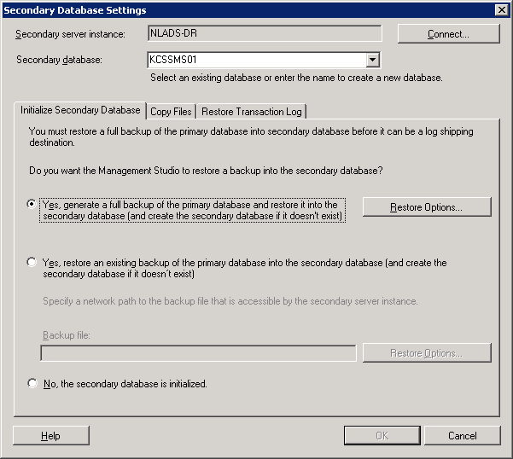
Click on the Add button to add secondary servers.
If u don’t have recent full back, then select fist option, if u have select second, to use existing back up select 3rd option.

Step 2.4.1: Give the secondary database file restore path
Click on the Restore options on the above screen, to specify the restore paths.
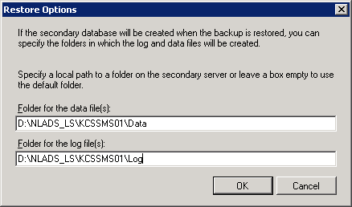

Step 2.4.2: Give the schedule copy, restore jobs details
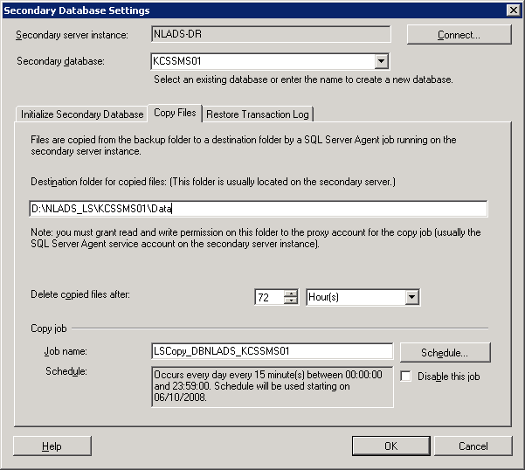
In the above screen, enter the secondary database name and destination folder for copying files. Also specify the retention period of this backup.

Click on schedule to specify the schedule.

Schedule to copy the log back up files.

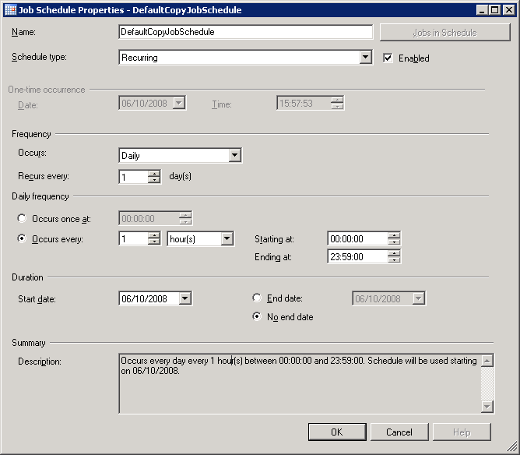

Click on the Restore Transaction Log. The below screen will be displayed:
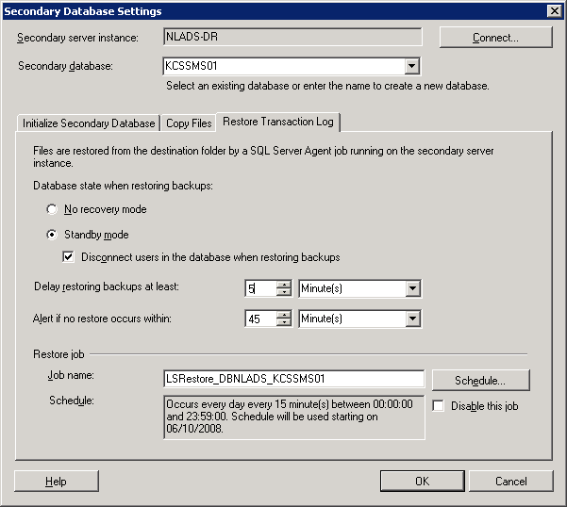

Specify the standby mode.
Click “schedule” to schedule the restore operation at secondary server.

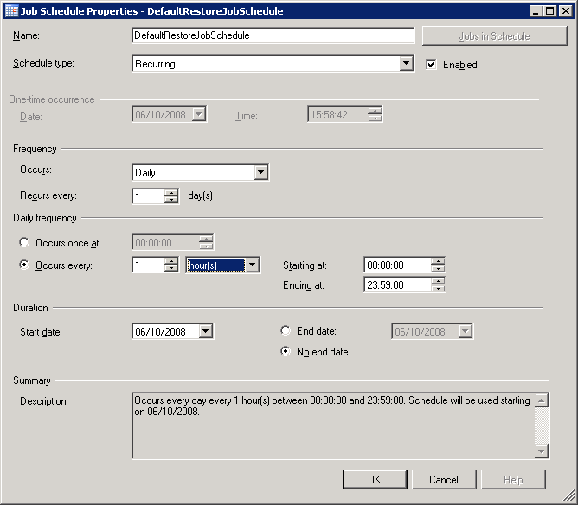
After Completion of schedule click OK.
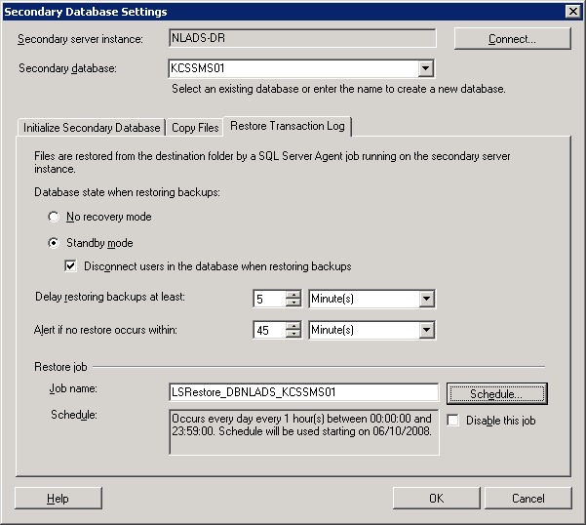
After completion of Secondary Database Settings click OK.

Once the jobs scheduling gets successfully completed, the following screen will be displayed
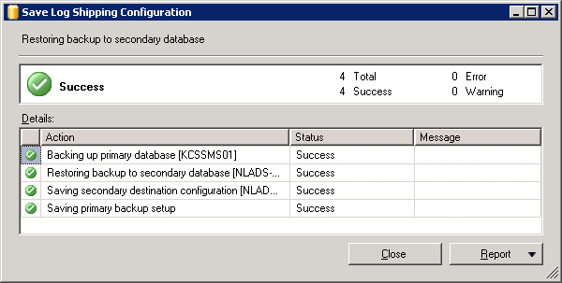

Reference
- http://technet.microsoft.com/en-us/library/ms187103.aspx
- http://msdn.microsoft.com/en-us/library/aa496029(v=SQL.80).aspx

